**Front End Engineering-II**

Project Report

Semester-IV (Batch-2022)

**DENSO TRANSPORTATION WEBSITE**

(TEMPLATE 33)



**Supervised By: Submitted By:**

Dr. Raveesh Samkaria Saksham

2210990761

G-31

**Department of Computer Science and Engineering**

**Chitkara University Institute of Engineering &Technology,**

**Chitkara University, Punjab**

# ABSTRACT

This project involves the development of a modern, responsive website for Denso Autos and Transportation using React, a popular JavaScript library for building user interfaces. The website aims to provide an engaging and seamless user experience for visitors, showcasing Denso’s automotive and transportation products and services. The primary objectives of this project are to enhance user interaction, improve accessibility, and deliver a visually appealing digital presence. The Denso Autos and Transportation website project showcases the effective use of modern web development technologies to create a user-friendly, interactive, and high-performing website. By leveraging React’s capabilities and adhering to best practices in responsive design, performance optimization, and accessibility, the project successfully delivers a robust digital platform for Denso to connect with its audience and promote its automotive and transportation solutions.

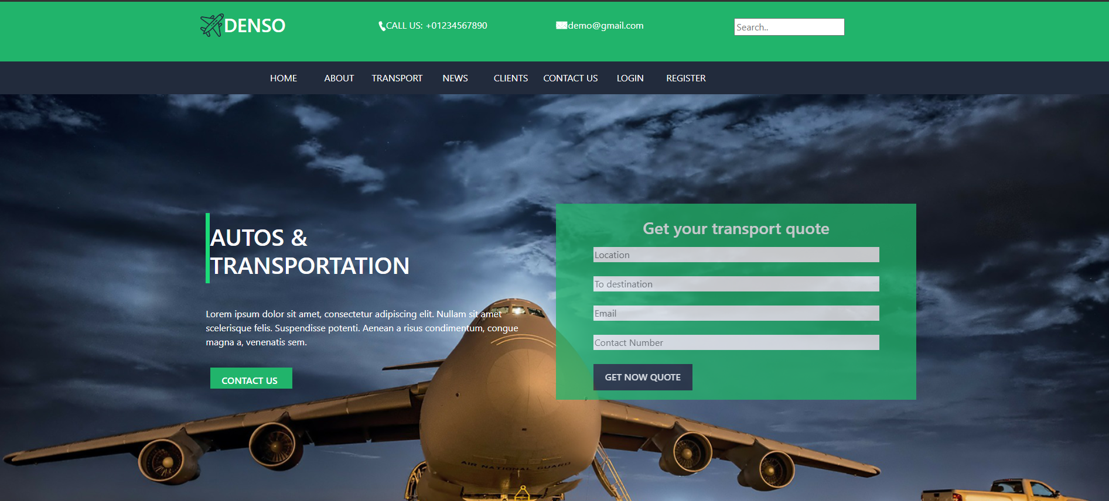

# INDEX

|  |  |  |
| --- | --- | --- |
| **S.No.** | **Title** | **Page Number(s)** |
| 1 | Introduction | 4 -5 |
| 2 | Problem Statement | 5 |
| 3 | Software Requirements | 5-6 |
| 4 | Proposed Design | 7-8 |
| 5 | File structure | 9-30 |
| 6 | Results | 31-33 |
| 7 | References | 33 |

# Introduction

In today's digital age, a robust online presence is crucial for businesses to connect with their customers and showcase their products and services. For companies in the automotive and transportation industry, an engaging and informative website can significantly enhance customer experience, drive sales, and build brand loyalty. This project focuses on developing a comprehensive website for Denso Autos and Transportation, a leading provider of automotive and transportation solutions, using the React framework. The primary goal of this project is to create a modern, responsive, and user-friendly website that effectively highlights Denso's offerings, facilitates easy navigation, and provides a seamless user experience across all devices.

**1.1Background:**

Denso Autos and Transportation is a renowned name in the automotive and transportation industry, known for its innovative products and solutions. With a commitment to quality and excellence, Denso has established itself as a leader in providing advanced automotive technology, including vehicle components, systems, and integrated solutions that enhance the safety, efficiency, and performance of vehicles.

**1.2Objectives:**

1. Enhanced User Experience:

- Intuitive Navigation: Design and implement a user-friendly navigation system that allows visitors to effortlessly explore different sections of the website.

- Smooth Scrolling: Integrate smooth scrolling functionality to improve the flow of navigation and enhance the overall user experience.

2. Responsive Design:

- Cross-Device Compatibility: Ensure the website is fully responsive, providing an optimal viewing and interaction experience across various devices, including desktops, tablets, and mobile phones.

- Consistent Visual Appeal: Use CSS framework Bootstrap to maintain a consistent and modern aesthetic across all screen sizes.

3. Scalability and Maintainability:

- Component-Based Architecture: Using React’s component-based architecture allows for the development of modular and reusable components, making the website easier to maintain and scale as Denso’s needs evolve.

# Problem Statement

Denso Autos and Transportation, a leading provider of automotive and transportation solutions, faces several challenges in its current digital presence. As the industry rapidly evolves and consumer expectations increase, it has become essential for Denso to offer a modern, user-friendly, and efficient online platform.

# Software Requirements

**I. Integrated Development Environment (IDE):**

Visual Studio Code (VS Code) will be utilized as the primary code editor and project management tool for its robust features, extensive extension ecosystem, and efficient workflow.

1. **Technology Requirements:** 
   * HTML5 (Hypertext Markup Language) will be employed for structuring the web application and creating the necessary elements for the clock components and user interface.
   * CSS3 (Cascading Style Sheets) will be used for styling the application, ensuring a visually appealing and coherent design across different components and screen sizes.
   * React: A JavaScript library for building user interfaces, particularly single-page applications. React’s component-based architecture allows for modular and reusable code.
2. **Smooth Scrolling:**

* React-scroll-l ibrary for implementing smooth scrolling functionality in React applications.

**IV Utility-first CSS Framework:**

Bootstrap, a popular front-end framework, will be utilized to simplify the styling process and create a modern, responsive design with minimal effort. Bootstrap's pre-built components and grid system will help achieve a consistent and professional look across different devices and screen sizes.

**V. Version Control and Collaboration:**

Git, a distributed version control system, will be utilized for tracking changes in the project codebase, enabling efficient collaboration, and facilitating code reviews and merges. The project repository will be hosted on GitHub, a popular platform for code hosting, collaboration, and issue tracking.

**VI. Browser Compatibility and Performance:**

The application will be developed with a focus on cross-browser compatibility, ensuring it functions correctly and consistently across the latest versions of popular web browsers. Performance optimization techniques will be implemented to ensure smooth and efficient

Rendering, minimizing resource consumption and providing an optimal experience.

# Proposed Design

**User Interface:**

* Design Principles: Consistency, simplicity, accessibility, and responsiveness are key design principles.
* Color Scheme and Typography: Utilizes Denso's brand colors and readable fonts for a professional look.
* Layout and Navigation: Features a sticky navigation bar for easy access to different sections and smooth scrolling between sections using `react-`scroll` library.
* Content Sections: Organized with clear grids or cards for products and services, with interactive elements like carousels.
* Performance Optimization: Implements lazy loading and code splitting to improve page load times and overall performance.

**Development Technologies:**

* HTML5 semantic elements will be utilized for structuring the application, ensuring proper semantics and accessibility.
* CSS will be responsible for styling the application, creating a visually appealing and cohesive design.
* React: JavaScript library for building user interfaces, used for creating a dynamic and responsive website.
* npm: Node package manager for installing and managing project dependencies.
* Bootstrap: CSS framework for developing responsive and mobile-first websites, used for additional styling and layout components

**User Experience:**

* Intuitive Navigation: Easy-to-use navigation with clear menus and links for seamless browsing.
* Responsive Design: Ensuring the website looks and functions well on various devices and screen sizes.
* Engaging Content: Using multimedia and interactive elements to keep users interested and informed.
* Accessibility: Making the website usable for all users, including those with disabilities, through features like keyboard navigation and screen reader compatibility.
* Performance Optimization: Improving loading times and overall performance for a smoother user experience.
* Feedback Mechanisms: Providing ways for users to give feedback and interact with the website.

**Testing and Quality Assurance:**

* Comprehensive testing, including manual and unit tests, will be conducted to ensure the application's functionality and user interface consistency.

**Documentation and Deployment:**

* Detailed documentation, including installation instructions, usage guidelines, and relevant information for developers and users, will be provided.
* The application will be deployed on a web server with a domain, ensuring accessibility and ease of use for end-users.
  1. **File Structure**

Establishing a meticulous organization of files and folders to uphold uniform file paths and a clutter-free arrangement.

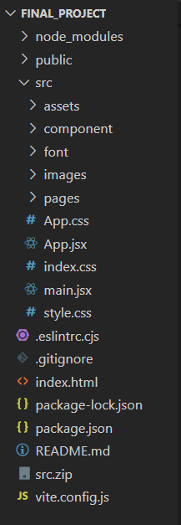

**4.1.1 Main file(App.jsx)**

import React from 'react';

import './style.css';

import 'bootstrap/dist/css/bootstrap.min.css';

import 'bootstrap/dist/js/bootstrap.min.js';

import Transport from "./pages/Transport";

import News from "./pages/News";

import React from 'react';

import './style.css';

import 'bootstrap/dist/css/bootstrap.min.css';

import 'bootstrap/dist/js/bootstrap.min.js';

import Transport from "./pages/Transport";

import Homepage from "./pages/Homepage";

import "slick-carousel/slick/slick.css";

import "slick-carousel/slick/slick-theme.css";

function App() {

  return (

    <div className="App">

      <Homepage />

    </div>

  );

}

export default App;

**4.1.2Components**

* **About.jsx**
* import React from "react";
* import image1 from "../images/testi_underline.png";
* import image2 from "../images/testi_user.png";
* function Testimonial() {
* return (
* <div className="container-fluid">
* <div className=" row testimonial">
* <div className="colsm-12">
* <div className="row testimonial_main">
* <div className="col-sm-4"></div>
* <div className="col-sm-4 pt-5">
* <h3>Testimonial</h3>
* <img className="welcome_img" src={image1} />
* </div>
* <div className="col-sm-4"></div>
* <div className="col-sm-1"></div>
* <div className="col-sm-10">
* <div className="owl-carousel owl-theme">
* <div className="item">
* <div className="row">
* <div className="col-sm-12">
* <div className="testi_user">
* <img src={image2} />
* </div>
* <div className="testi_head">
* <br />
* <h4>Consectetur</h4>
* </div>
* </div>
* <div className="col-sm-12 testi_para">
* <p>
* Lorem ipsum dolor sit amet, consectetur adipiscing elit.
* Nullam sit amet scelerisque felis Totam distinctio accusamus, soluta aperiam tenetur eveniet quas odio, dolores rem culpa dicta enim natus dolor doloribus ea placeat corrupti.
* </p>
* </div>
* </div>
* </div>
* <div className="item">
* <div className="row">
* <div className="col-sm-12">
* <div className="testi_user">
* <img src={image2} />
* </div>
* <div className="testi_head">
* <br />
* <h4>Consectetur</h4>
* </div>
* </div>
* <div className="col-sm-12 testi_para">
* <p>
* Lorem ipsum dolor sit amet, consectetur adipiscing elit.
* Nullam sit amet scelerisque felis Totam distinctio accusamus, soluta aperiam tenetur eveniet quas odio, dolores rem culpa dicta enim natus dolor doloribus ea placeat corrupti.
* </p>
* </div>
* </div>
* </div>
* </div>
* </div>
* </div>
* </div>
* </div>
* </div>
* );
* }
* export default Testimonial;
* **Contact.jsx**
* import React from "react";
* import image1 from "../images/heading_underline.png";
* function Contact() {
* return (
* <div className="container-fluid">
* <div className="row contact">
* <div className="col-sm-3"></div>
* <div className="col-sm-6">
* <h1>REQUEST A CALLBACK</h1>
* <img className="about_left_img" src={image1} />
* </div>
* <div className="col-sm-3"></div>
* <div className="col-sm-3"></div>
* <div className="col-sm-6">
* <form className="callback_form">
* <input type="text" placeholder="Name" required />
* <br />
* <br />
* <input type="email" placeholder="Email" required />
* <br />
* <br />
* <input
* type="tel"
* placeholder="Phone Number"
* className="call-back-form"
* required
* style={{ backgroundColor: 'white', color: 'black' }}
* />
* <br />
* <br />
* <textarea
* type="textarea"
* className="callback_msg"
* placeholder="Message"
* required
* ></textarea>
* <br />
* <br />
* <button>SEND</button>
* </form>
* </div>
* <div className="col-sm-3"></div>
* <div className="col-sm-12">
* <br />
* <br />
* </div>
* </div>
* </div>
* );
* }
* export default Contact;
* **Footer.jsx**
* import React from "react";
* import image1 from "../images/fb-icon.png";
* import image2 from "../images/twitter.png";
* import image3 from "../images/linkedin-icon.png";
* import image4 from "../images/instagram-icon.png";
* function Footer() {
* return (
* <div className="container-fluid">
* <div className="row footer">
* <div className="col-sm-12">
* <br />
* </div>
* <div className="col-sm-1"></div>
* <div className="col-sm-5 p-2 footer_left">
* <div className="row">
* <div className="col-sm-2"></div>
* <div className="col-sm-8 footer_left_head">
* <h1>DENSO</h1>
* </div>
* <div className="col-sm-2"></div>
* <div className="col-sm-2"></div>
* <div className="col-sm-8">
* <p>
* Lorem ipsum dolor sit amet, consectetur adipiscing elit. Nullam
* sit amet scelerisque felis. Suspendisse potenti. Aenean a risus
* condimentum, congue magna a, venenatis sem. Praesent tempus,
* purus sit amet bibendum mollis, urna elit egestas dui, a finibus
* elit massa vitae est. Praesent ut elementum justo. Morbi eu
* lectus et augue commodo cursus id sit amet massa. Vivamus
* tristique tellus id velit tempor hendrerit.
* </p>
* </div>
* <div className="col-sm-2"></div>
* </div>
* <div className="footer_icon pt-1 pb-1 p-5">
* <ul>
* <li>
* <a href="#">
* <img src={image1} />
* </a>
* </li>
* <li>
* <a href="#">
* <img src={image2} />
* </a>
* </li>
* <li>
* <a href="">
* <img src={image3} />
* </a>
* </li>
* <li>
* <a href="">
* <img src={image4} />
* </a>
* </li>
* </ul>
* </div>
* </div>
* <div className="col-sm-2 footer_icon_right footer_right">
* <ul>
* <li>
* <h4>Information</h4>
* </li>
* <li>There are many</li>
* <li>varitions of pos-</li>
* <li>sages of Lorem</li>
* <li>Ipsum available.</li>
* <li>but the majority</li>
* </ul>
* </div>
* <div className="col-sm-2 footer_icon_right">
* <ul>
* <li>
* <h4>Helpful Links</h4>
* </li>
* <li>There are many</li>
* <li>varitions of pos-</li>
* <li>sages of Lorem</li>
* <li>Ipsum available.</li>
* <li>but the majority</li>
* </ul>
* </div>
* <div className="col-sm-2 footer_icon_right">
* <ul>
* <li>
* <h4>Supported</h4>
* </li>
* <li>There are many</li>
* <li>varitions of pos-</li>
* <li>sages of Lorem</li>
* <li>Ipsum available.</li>
* <li>but the majority</li>
* </ul>
* </div>
* <div className="col-sm-12">
* <br />
* </div>
* <div className="col-sm-12 end p-3 pb-1">
* <p>&copy;2019 All Rights Reserved. Free html Templates</p>
* </div>
* </div>
* </div>
* );
* }
* export default Footer;
* **Footer1.jsx**
* import React from "react";
* import image1 from "../images//call.png";
* import image2 from "../images/map.png";
* import image3 from "../images/mail.png";
* function Footer1() {
* return (
* <div className="container-fluid">
* <div className="row footer1">
* <div className="col-sm-1"></div>
* <div className="col-sm-2 pt-2">
* <div className="foot_cont pt-2">
* <img src={image1} />
* <p>&ensp;Call Now &nbsp; +01 1234567890</p>
* </div>
* </div>
* <div className="col-sm-2"></div>
* <div className="col-sm-2 pt-2">
* <div className="foot_cont pt-2">
* <img src={image2} />
* <p> &ensp;Location</p>
* </div>
* </div>
* <div className="col-sm-2"></div>
* <div className="col-sm-2 pt-2">
* <div className="foot_cont pt-2">
* <img src={image3} />
* <p>&ensp;demo@gmail.com</p>
* </div>
* </div>
* <div className="col-sm-1"></div>
* </div>
* </div>
* );
* }
* export default Footer1;
* **Header.jsx**
* import React from "react";
* import image1 from "../images/logo_navbar.png";
* import image2 from "../images/call.png";
* import image3 from "../images/mail.png";
* function Header() {
* return (
* <div className="container-fluid">
* <div className="row navbar1">
* <div className="col-2"></div>
* <div className="col-8 content">
* <ul class="nav nav-pills nav-justified">
* <li class="nav-item">
* <div className="logo_head">
* <img src={image1} />
* <p>
* <h2>DENSO</h2>
* </p>
* </div>
* </li>
* <li class="nav-item">
* <div className="logo_head pt-2">
* <img src={image2} style={{ paddingTop: "5px" }} />
* <p>CALL US: +01234567890</p>
* </div>
* </li>
* <li class="nav-item">
* <div className="logo_head pt-2">
* <img src={image3} style={{ paddingTop: "5px" }} />
* <p>demo@gmail.com</p>
* </div>
* </li>
* <li class="nav-item">
* <div className="pt-2">
* <form className="example">
* <input type="text" placeholder="Search.." name="search" />
* </form>
* </div>
* </li>
* </ul>
* </div>
* <div className="col-2"></div>
* </div>
* </div>
* );
* }
* export default Header;
* **Home.jsx**
* import React from "react";
* import image1 from "../images/main_hz_line.png";
* function Home() {
* return (
* <div className="container-fluid">
* <div className="main row p-3">
* <div className="col-sm-12">
* <br />
* </div>
* <div className="col-sm-2"></div>
* <div className="col-sm-8 ">
* <div className="row p-2">
* <div className="col-6 p-2">
* <div className="main_cont mb-2 p-2">
* <img src={image1} />
* <h1 className="mt-3 heading pop">
* AUTOS &<br /> TRANSPORTATION
* </h1>
* </div>
* <p className="mt-4 mb-4 p-2">
* Lorem ipsum dolor sit amet, consectetur adipiscing elit. Nullam
* sit amet scelerisque felis. Suspendisse potenti. Aenean a risus
* condimentum, congue magna a, venenatis sem.{" "}
* </p>
* &emsp;<button className="main_but mb-3">CONTACT US &emsp;</button>
* </div>
* <div className=" col-sm-6 main_form mb-3 ">
* <h3 className="p-4 pb-2">Get your transport quote</h3>
* <div className="row">
* <div className="col-sm-1"></div>
* <div className="col-sm-10">
* <form>
* <input
* className="main_form_inp"
* type="text"
* placeholder="Location"
* required
* />
* <br />
* <br />
* <input
* className="main_form_inp"
* type="text"
* placeholder="To destination"
* required
* />
* <br />
* <br />
* <input
* className="main_form_inp"
* type="email"
* placeholder="Email"
* required
* />
* <br />
* <br />
* <input
* className="main_form_inp"
* type="tel"
* placeholder="Contact"
* required
* />
* <br />
* <br />
* <button className="main_form_but mb-3">
* GET NOW QUOTE
* </button>
* </form>
* </div>
* <div className="col-sm-1"></div>
* </div>
* </div>
* </div>
* </div>
* <div className="col-2"></div>
* </div>
* </div>
* );
* }
* export default Home;
* **Navbar.jsx**
* import React from 'react';
* function Navbar() {
* return (
* <div className='container-fluid'>
* <div className="navbar2 row">
* <div className='col-sm-2'></div>
* <div className='col-sm-8'>
* <nav className="navbar navbar-justified navbar-expand-lg text-white">
* <div className="container-fluid">
* <div className="navbar-brand">&emsp;&emsp;&emsp;&emsp;</div>
* <button className="navbar-toggler" type="button" data-bs-toggle="collapse" data-bs-target="#navbarNavDropdown" aria-controls="navbarNavDropdown" aria-expanded="false" aria-label="Toggle navigation">
* <span className="navbar-toggler-icon"></span>
* </button>
* <div className="collapse navbar-collapse" id="navbarNavDropdown">
* <ul className="navbar-nav">
* <li className="nav-item">
* <div className='nabavr_div'>
* <a className="nav-link" href="#home" style={{ color: 'white' }}><div>HOME</div></a>
* </div>
* </li>
* <li className="nav-item">
* <div className='nabavr_div'>
* <a className="nav-link" href="#about" style={{ color: 'white' }}><div>ABOUT</div></a>
* </div>
* </li>
* <li className="nav-item">
* <div className='nabavr_div'>
* <a className="nav-link" href="#welcome" style={{ color: 'white' }}><div>TRANSPORT</div></a>
* </div>
* </li>
* {/* <li className="nav-item">
* <div className='nabavr_div'>
* <a className="nav-link" href="#service" style={{ color: 'white' }}><div>SERVICE</div></a>
* </div>
* </li> */}
* <li className="nav-item">
* <div className='nabavr_div'>
* <a className="nav-link" href="#notice" style={{ color: 'white' }}><div>NEWS</div></a>
* </div>
* </li>
* <li className="nav-item">
* <div className='nabavr_div'>
* <a className="nav-link" href="#testimonial" style={{ color: 'white' }}><div>CLIENTS</div></a>
* </div>
* </li>
* <li className="nav-item">
* <div className='nabavr_div'>
* <a className="nav-link" href="#contact" style={{ color: 'white' }}><div>CONTACT US</div></a>
* </div>
* </li>
* <li className="nav-item">
* <div className='nabavr_div'>
* <a className="nav-link" href="#" style={{ color: 'white' }}><div>LOGIN</div></a>
* </div>
* </li>
* <li className="nav-item">
* <div className='nabavr_div'>
* <a className="nav-link" href="#" style={{ color: 'white' }}><div>REGISTER</div></a>
* </div>
* </li>
* </ul>
* </div>
* </div>
* </nav>
* </div>
* <div className='col-sm-2'></div>
* </div>
* </div>
* );
* }
* export default Navbar;
* **Notice.jsx**
* import React from "react";
* import image1 from "../images/heading_underline.png";
* import image2 from "../images/news_step.png";
* import image3 from "../images/news1.png";
* import image4 from "../images/news2.png";
* import image5 from "../images/news3.png";
* function Notice() {
* return (
* <div className="container-fluid">
* <div className=" row news pb-5">
* <div className="col-sm-4"></div>
* <div className="col-sm-4 pt-5 pb-3">
* <h3>LATEST NEWS AND EVENTS</h3>
* <img className="about_left_img" src={image1} />
* </div>
* <div className="col-sm-4"></div>
* <div className="col-sm-4 p-4 pt-1">
* <div className="news2_bg">
* <img className="news_img" src={image3} />
* <div className="news1_bg">
* <div className="news_step1">
* <img src={image2} />
* <p>
* 01
* <br />
* Step
* </p>
* </div>
* <div className="pt-3 news1">
* <h6>LIBERALISATION OF AIR CARGO INDUSTRY</h6>
* <p className="p-4 pt-2">
* Lorem ipsum dolor sit amet, consectetur adipiscing elit.
* Nullam sit amet scelerisque felis. Suspendisse potenti. Aenean
* a risus condimentum, congue magna a, venenatis sem. Praesent
* tempus, purus sit amet bibendum mollis, urna elit egestas dui,
* </p>
* </div>
* </div>
* </div>
* </div>
* <div className="col-sm-4 p-4 pt-1 ">
* <div className="news2_bg">
* <img className="news_img" src={image4} />
* <div className="news_step1">
* <img src={image2} />
* <p>
* 02
* <br />
* Step
* </p>
* </div>
* <div className="pt-3 news1">
* <h6>NEW WAREHOUSE NOW OPERATIONAL</h6>
* <p className="p-4 pt-2">
* Lorem ipsum dolor sit amet, consectetur adipiscing elit. Nullam
* sit amet scelerisque felis. Suspendisse potenti. Aenean a risus
* condimentum, congue magna a, venenatis sem. Praesent tempus,
* purus sit amet bibendum mollis, urna elit egestas dui,
* </p>
* </div>
* </div>
* </div>
* <div className="col-sm-4 p-4 pt-1">
* <div className="news2_bg">
* <img className="news_img" src={image5} />
* <div className="news1_bg">
* <div className="news_step1">
* <img src={image2} />
* <p>
* 03
* <br />
* Step
* </p>
* </div>
* <div className="pt-3 news1">
* <h6>NEW TRUCKS ARRIVING</h6>
* <p className="p-4 pt-2">
* Lorem ipsum dolor sit amet, consectetur adipiscing elit.
* Nullam sit amet scelerisque felis. Suspendisse potenti. Aenean
* a risus condimentum, congue magna a, venenatis sem. Praesent
* tempus, purus sit amet bibendum mollis, urna elit egestas dui,
* </p>
* </div>
* </div>
* </div>
* </div>
* <div className="col-sm-5"></div>
* <div className="col-sm-2">
* <button className="services_but">&ensp; Read More &ensp;</button>
* </div>
* <div className="col-sm-5"></div>
* </div>
* </div>
* );
* }
* export default Notice;
* **Service.jsx**
* import React from "react";
* import image1 from "../images/heading_underline.png";
* import image2 from "../images/services1.png";
* import image3 from "../images/services2.png";
* import image4 from "../images/services3.png";
* import image5 from "../images/services4.png";
* import image6 from "../images/services5.png";
* function Service() {
* return (
* <div className="container-fluid">
* <div className="row services p-5">
* <div className="col-sm-12"></div>
* <div className="col-sm-4"></div>
* <div className="col-sm-4">
* <h1>SERVICES</h1>
* <img src={image1} className="welcome_img" />
* </div>
* <div className="col-sm-4"></div>
* <div className="col-sm-2"></div>
* <div className="col-sm-8">
* <p>
* Lorem ipsum dolor sit amet, consectetur adipiscing elit. Nullam sit
* amet scelerisque felis. Suspendisse potenti. Aenean a risus
* condimentum, congue magna a, venenatis sem.
* </p>
* </div>
* <div className="col-sm-2"></div>
* <div className="col-sm-1"></div>
* <div className="col-sm-10">
* <div className="row">
* <div className="col-sm-2 p-1 m-3">
* <img src={image2} />
* <br />
* FLY ANYWHERE
* </div>
* <div className="col-sm-2 p-1 m-3">
* <img src={image3} />
* <br />
* CARGO SERVICE
* </div>
* <div className="col-sm-2 p-1 m-3">
* <img src={image4} />
* <br />
* COURIER SERVICES
* </div>
* <div className="col-sm-2 p-1 m-3">
* <img src={image5} />
* <br />
* BOX STORAGE
* </div>
* <div className="col-sm-2 p-1 m-3">
* <img src={image6} />
* <br />
* 100% SAFE
* </div>
* </div>
* </div>
* <div className="col-sm-1"></div>
* <div className="col-sm-12 mb-3"></div>
* <div className="col-sm-4"></div>
* <div className="col-sm-4">
* <button className="services_but p-5 pt-2 pb-2">READ MORE</button>
* </div>
* <div className="col-sm-4"></div>
* </div>
* </div>
* );
* }
* export default Service;
* **Testimonial.jsx**
* import React from "react";
* import image1 from "../images/testi_underline.png";
* import image2 from "../images/testi_user.png";
* function Testimonial() {
* return (
* <div className="container-fluid">
* <div className=" row testimonial">
* <div className="colsm-12">
* <div className="row testimonial_main">
* <div className="col-sm-4"></div>
* <div className="col-sm-4 pt-5">
* <h3>Testimonial</h3>
* <img className="welcome_img" src={image1} />
* </div>
* <div className="col-sm-4"></div>
* <div className="col-sm-1"></div>
* <div className="col-sm-10">
* <div className="owl-carousel owl-theme">
* <div className="item">
* <div className="row">
* <div className="col-sm-12">
* <div className="testi_user">
* <img src={image2} />
* </div>
* <div className="testi_head">
* <br />
* <h4>Consectetur</h4>
* </div>
* </div>
* <div className="col-sm-12 testi_para">
* <p>
* Lorem ipsum dolor sit amet, consectetur adipiscing elit.
* Nullam sit amet scelerisque felis Totam distinctio accusamus, soluta aperiam tenetur eveniet quas odio, dolores rem culpa dicta enim natus dolor doloribus ea placeat corrupti.
* </p>
* </div>
* </div>
* </div>
* <div className="item">
* <div className="row">
* <div className="col-sm-12">
* <div className="testi_user">
* <img src={image2} />
* </div>
* <div className="testi_head">
* <br />
* <h4>Consectetur</h4>
* </div>
* </div>
* <div className="col-sm-12 testi_para">
* <p>
* Lorem ipsum dolor sit amet, consectetur adipiscing elit.
* Nullam sit amet scelerisque felis Totam distinctio accusamus, soluta aperiam tenetur eveniet quas odio, dolores rem culpa dicta enim natus dolor doloribus ea placeat corrupti.
* </p>
* </div>
* </div>
* </div>
* </div>
* </div>
* </div>
* </div>
* </div>
* </div>
* );
* }
* export default Testimonial;
* **Welcome.jsx**
* import React from "react";
* import image1 from "../images/heading_underline.png";
* function Welcome() {
* return (
* <div className="container-fluid">
* <div className="row welcome p-5">
* <div className="col-sm-12"></div>
* <div className="col-sm-4"></div>
* <div className="col-sm-4">
* <h1>WELCOME TO DENSO TRANSPORT</h1>
* <img src={image1} className="welcome_img" />
* </div>
* <div className="col-sm-4"></div>
* <div className="col-sm-2"></div>
* <div className="col-sm-8">
* <p>
* Lorem ipsum dolor sit amet, consectetur adipiscing elit. Nullam sit
* amet scelerisque felis. Suspendisse potenti. Aenean a risus
* condimentum, congue magna a, venenatis sem. Praesent tempus, purus
* sit amet bibendum mollis, urna elit egestas dui, a finibus elit
* massa vitae est. Praesent ut elementum justo. Morbi eu lectus et
* augue commodo cursus id sit amet massa. Vivamus tristique tellus id
* velit tempor hendrerit.{" "}
* </p>
* </div>
* <div className="col-sm-2"></div>
* </div>
* </div>
* );
* }
* export default Welcome;

**5.Results**

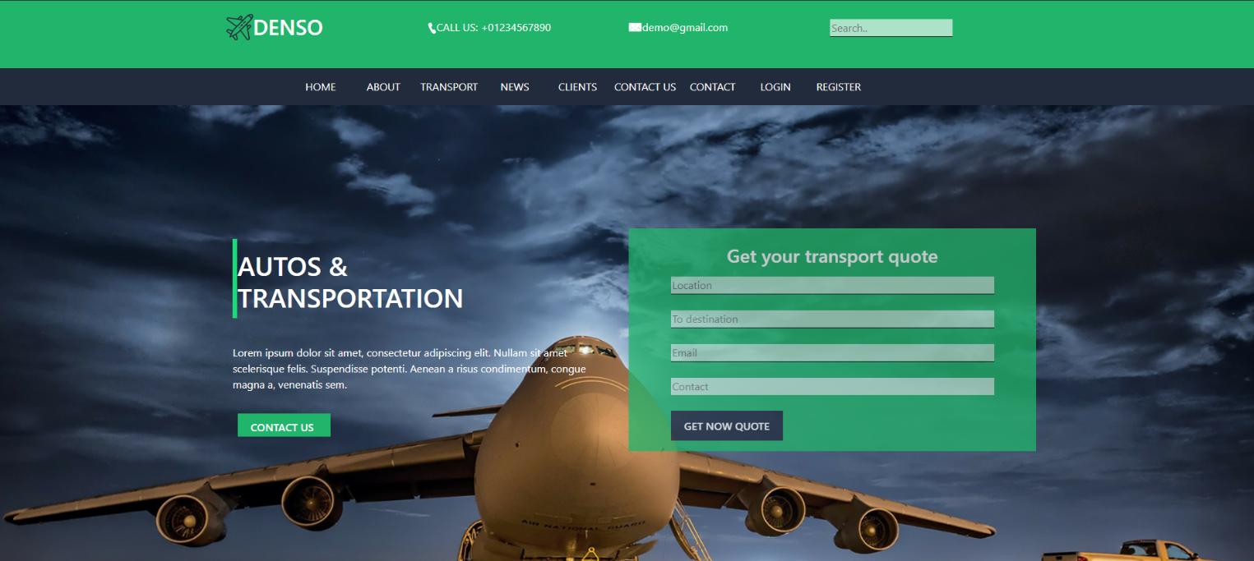

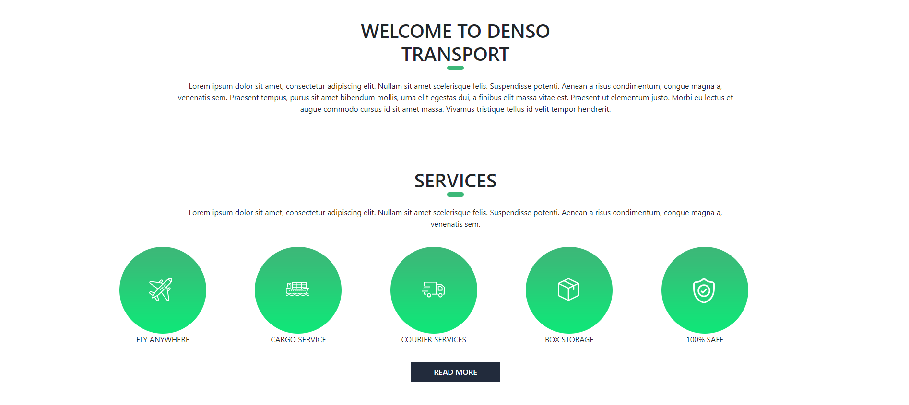

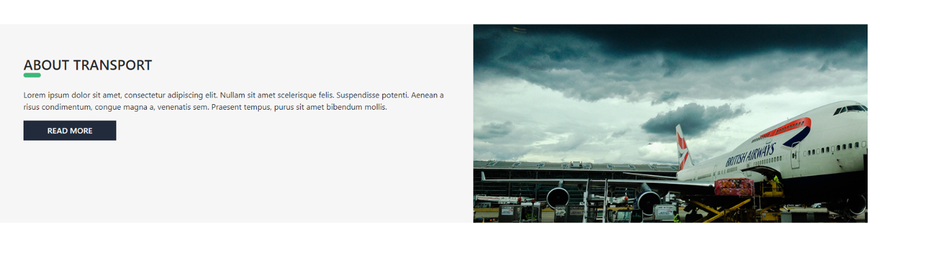

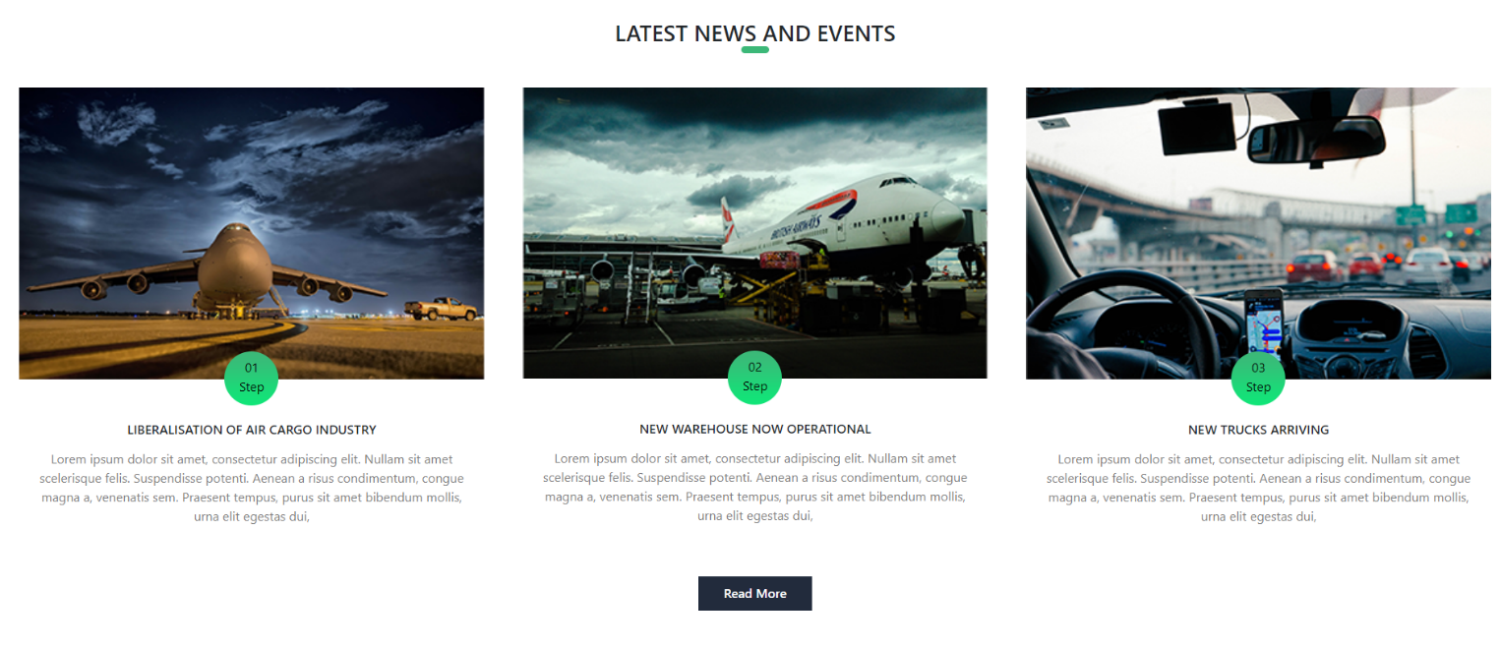

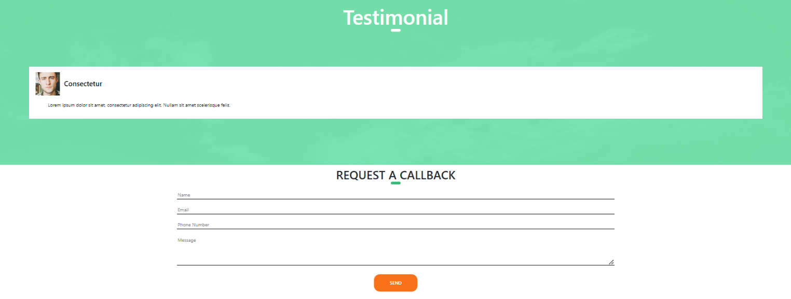

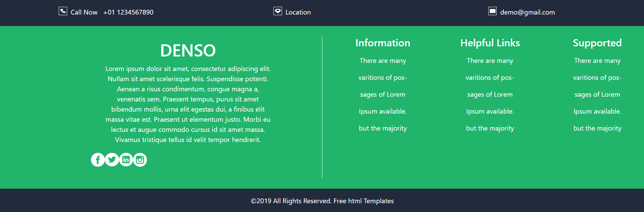

# References

* **Mozilla Developer Network (MDN) - HTML, CSS, JS Documentation:**

Website: https://developer.mozilla.org/

Description: MDN offers comprehensive documentation on HTML, CSS, and JavaScript, covering everything from basic syntax to advanced concepts

**6.References**

* **W3Schools - HTML, CSS, JavaScript Tutorials:**

Website: https://www.w3schools.com/

Description: W3Schools provides beginner-friendly tutorials and references for HTML, CSS, and JavaScript, along with interactive code examples.

* **Bootstrap Documentation:**

Website: https://getbootstrap.com/

Description: The official Bootstrap documentation provides detailed guidance on using Bootstrap CSS for building modern and responsive web interfaces. It includes utility classes, customization options, and best practices.

* **React Documentation:**

Website: <https://www.w3schools.com/react/default.asp>

Description: The new Quick Start teaches modern React and includes live examples. This page is an overview of the React documentation and related resources. React is a JavaScript library for building user interfaces.